Laporan pak eko modul1
Penggunaan MATLAB untuk Analisis Step-Response pada Sistem Kendali – Bag. 1
1.1
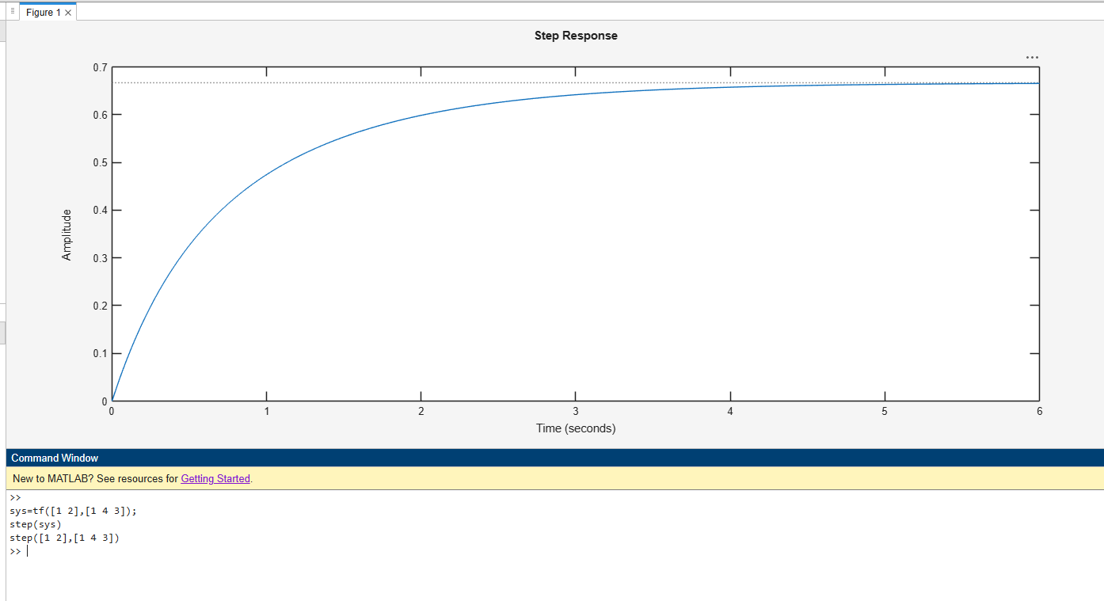
Figure 1pp
>> sys=tf([1 2],[1 4 3]);
step(sys)
>> step([1 2],[1 4 3])
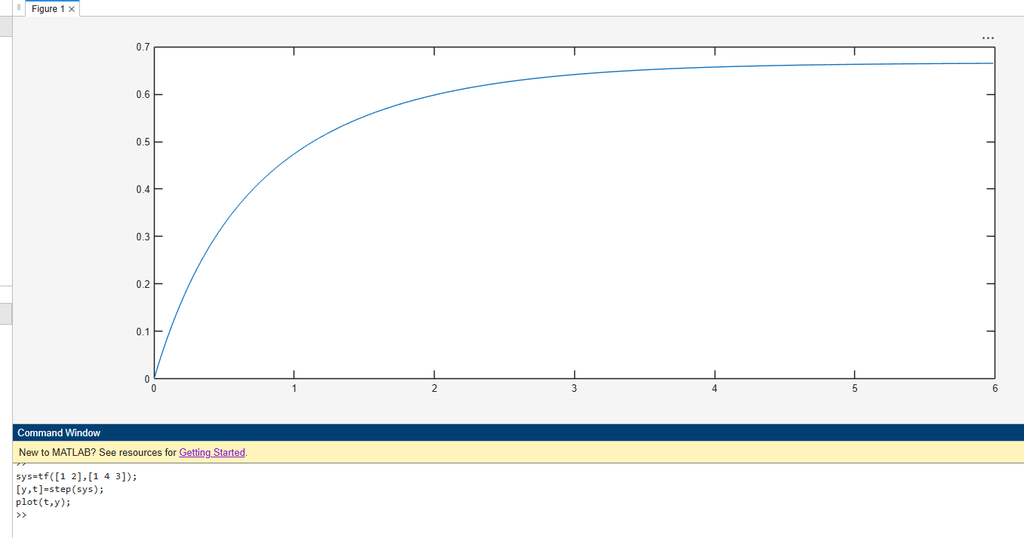
Figure 2ll
>> sys=tf([1 2],[1 4 3]);
[y,t]=step(sys);
plot(t,y);

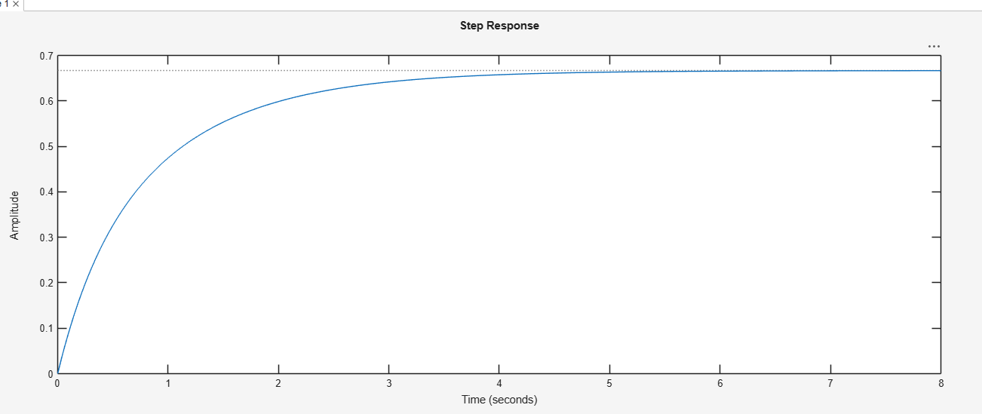
Figure 3kk
>> sys=tf([1 2],[1 4 3]);
step(sys,8);
>> step([1 2],[1 4 3],8)
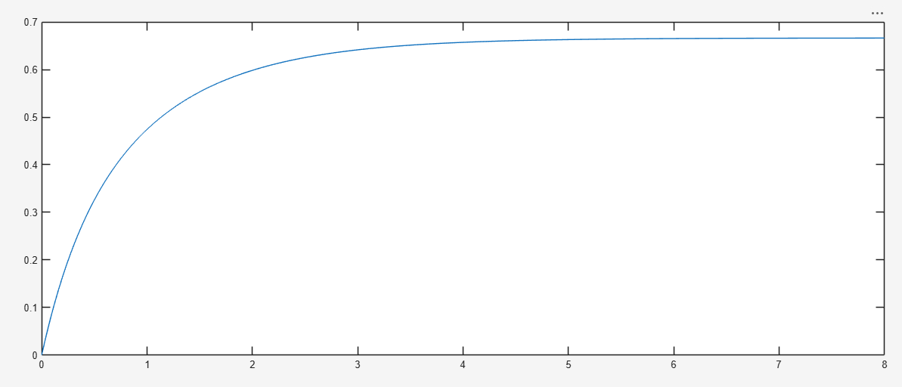
Figure 4151
>> sys=tf([1 2],[1 4 3]);
>> [y,t]=step(sys,8);
>> plot(t,y);

1.2
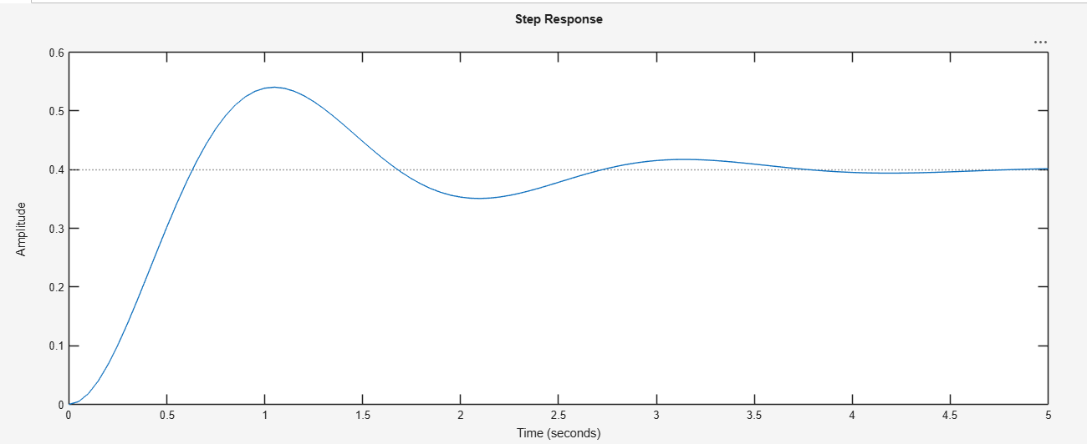
Figure 588
>> sys = tf(4,[1 2 10]);
t = 0:0.05:5;
step(sys,t);
1.3
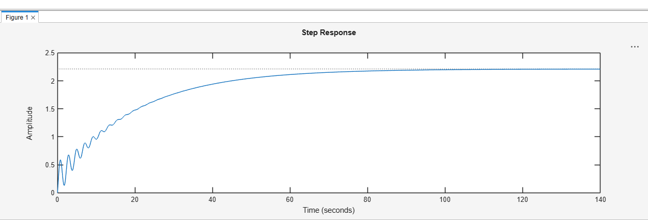
Figure 6hu
>> sys = zpk(-1,[-0.2+3j,-0.2-3j],1) * tf([1 1],[1 0.05])
step(sys)
sys =
(s+1)^2
----------------------------
(s+0.05) (s^2 + 0.4s + 9.04)
Continuous-time zero/pole/gain model.

1.5
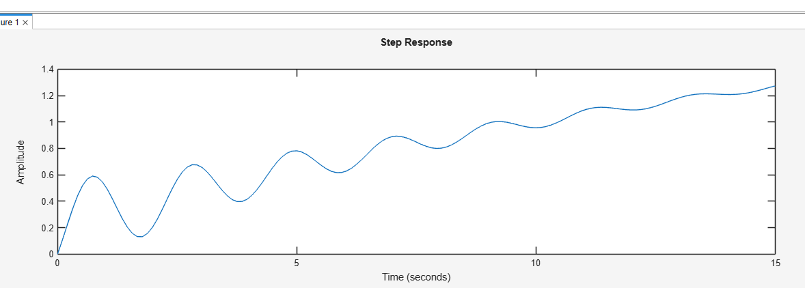
Figure 7hv
>> sys = zpk(-1,[-0.2+3j,-0.2-3j],1) * tf([1 1],[1 0.05])
% step(sys)
step(sys,15)
sys =
(s+1)^2
----------------------------
(s+0.05) (s^2 + 0.4s + 9.04)
Continuous-time zero/pole/gain model.
Model Properties
1.6
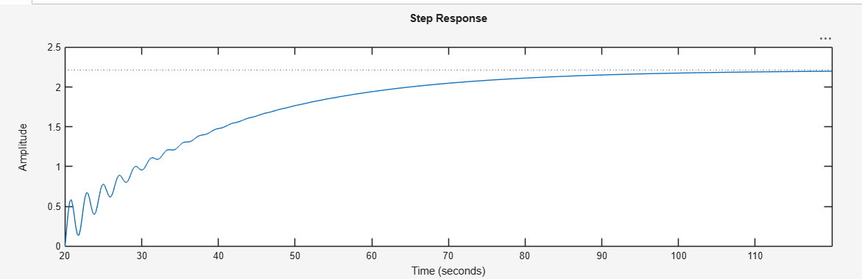
Figure 8jjh
>> sys = zpk(-1,[-0.2+3j,-0.2-3j],1) * tf([1 1],[1 0.05])
% step(sys)
% step(sys,15)
t = 20:0.2:120;
step(sys,t)
sys =
(s+1)^2
----------------------------
(s+0.05) (s^2 + 0.4s + 9.04)
Penggunaan MATLAB untuk Analisis Step-Response pada Sistem Kendali – Bag. 2
1.6
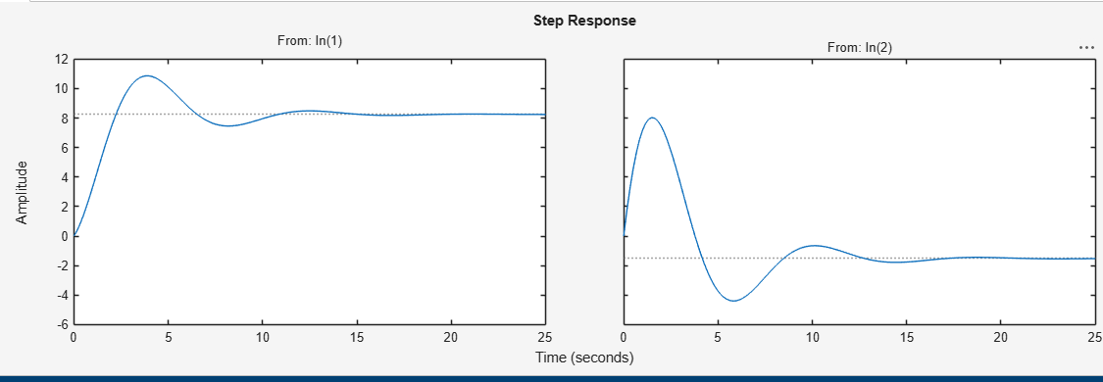
>> A = [-0.5572,-0.7814;0.7814,0];
B = [1,-1;0,2];
C = [1.9691,6.4493];
sys = ss(A,B,C,0);
step(sys)
tf(sys)
ans =
From input 1 to output:
1.969 s + 5.039
-----------------------
s^2 + 0.5572 s + 0.6106
From input 2 to output:
10.93 s - 0.9297
-----------------------
s^2 + 0.5572 s + 0.6106
1.7
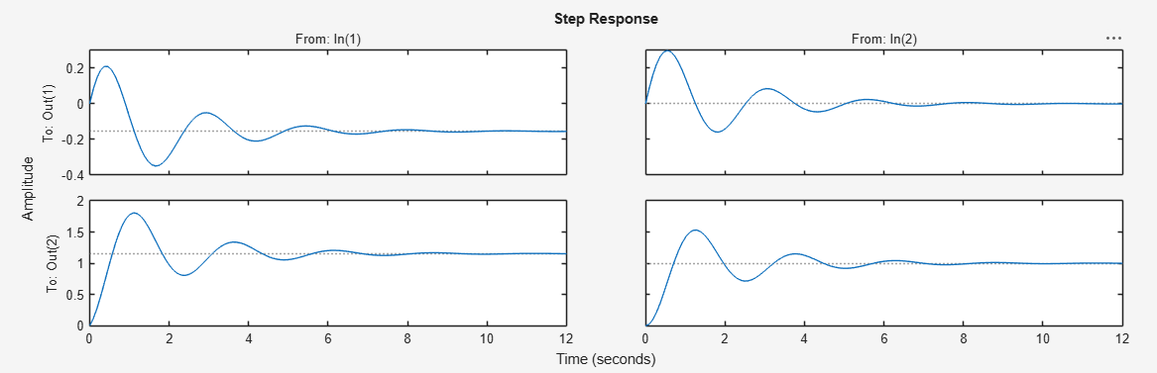
>> A = [-1 -1; 6.5 0];
B = [1 1;1 0];
C = [1 0; 0 1];
D=[0 0; 0 0];
% sys = ss(A,B,C,D);
% step(sys)
% tf(sys)
step(A,B,C,D)
>>
Untuk memplot dua kurva respons langkah untuk input u1 dalam satu diagram, dan dua
kurva respons langkah untuk input u2 dalam diagram lain, kita dapat menggunakan
perintah:

step(A,B, C,D, 1)
step(A,B, C,D, 2)

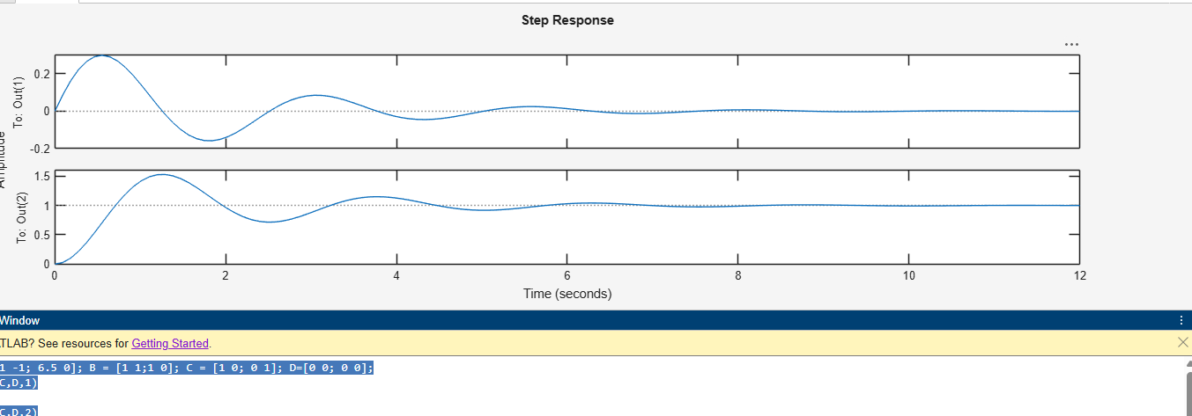
>> A = [-1 -1; 6.5 0]; B = [1 1;1 0]; C = [1 0; 0 1]; D=[0 0; 0 0];
step(A,B,C,D,1)
figure;
step(A,B,C,D,2)
>>
Step-Response dari Discrete-Time System

Penggunaan MATLAB untuk Analisis Step-Response pada Sistem Kendali – Bag. 3
1.9
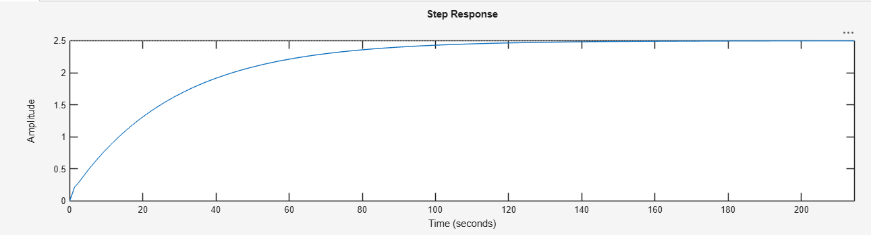
>> sys = tf([1 5 5],[1 1.65 56.5 2]);
step(sys)
S = stepinfo(sys)
S =
struct with fields:
RiseTime: 62.1210
TransientTime: 109.4246
SettlingTime: 109.4246
SettlingMin: 2.2586
SettlingMax: 2.4984
Overshoot: 0
Undershoot: 0
Peak: 2.4984
PeakTime: 206.6433

